Stripe Online Payment Configuration
Step 1: Select events. You're on this step now. Don't tick anything under Payment Method. Select only these three:
- Checkout → checkout.session.completed and checkout.session.expired. Expand the Checkout group, which is higher up in the list.
- Payment Intent → payment_intent.payment_failed. Expand the Payment Intent group, which is just above where you are.
The search box at the top of the list can help you find them. Then click Continue.
Step 2: Choose destination type. Pick Webhook endpoint.
Step 3: Configure your destination.
- Endpoint URL: https://<your-api-host>/api/webhooks/stripe. This is the WebAPI you created in C# and It must be a public HTTPS URL, so localhost won't work here.
- NOTE: If you're only testing locally, cancel this wizard and use stripe listen --forward-to localhost:5144/api/webhooks/stripe, which prints the whsec_... secret for you.
  - Follow this steps:
The Stripe CLI is a command-line program you install on your computer. It isn't in the dashboard.
1. Install it (Windows): use one of these.
winget: winget install Stripe.StripeCli (This tried in cmd and it works!)
Scoop: scoop bucket add stripe https://github.com/stripe/scoop-stripe-cli.git then scoop install stripe
Manual download: get the Windows zip from https://github.com/stripe/stripe-cli/releases/latest, extract stripe.exe, and put its folder on your PATH.
Open a new terminal afterwards and check it with stripe --version.
2. Log in: (Continue here!!!!)
stripe login
This opens your browser. Click Allow access. Log in with the same Stripe account and sandbox you're using in the dashboard.
3. Start forwarding events: keep your API running first (dotnet run --project src/OnlineEbookShopV1.Api listens on http://localhost:5144).
stripe listen --forward-to localhost:5144/api/webhooks/stripe
It prints:
Ready! Your webhook signing secret is whsec_xxxxxxxx
4. Save that secret:
dotnet user-secrets --project src/OnlineEbookShopV1.Api set "Stripe:WebhookSecret" "whsec_xxxxxxxx"
Restart the API so it picks up the new secret. Leave the stripe listen window open while you test, because events only reach your API while it's running.
To check it's working, run stripe trigger checkout.session.completed in a second terminal. You should see the event forwarded in the listen window.
- Give it a name, then create it.
Getting the secret: after creation, open the destination and click Reveal under Signing secret. Copy the whsec_... value into your config:
dotnet user-secrets --project src/OnlineEbookShopV1.Api set "Stripe:WebhookSecret" "whsec_..."
If you don't have a deployed API yet, use the Stripe CLI route for now. Create the dashboard destination when you deploy to staging.
Get the SecretKey (publishableKey) and Secret (SecretKey) here:
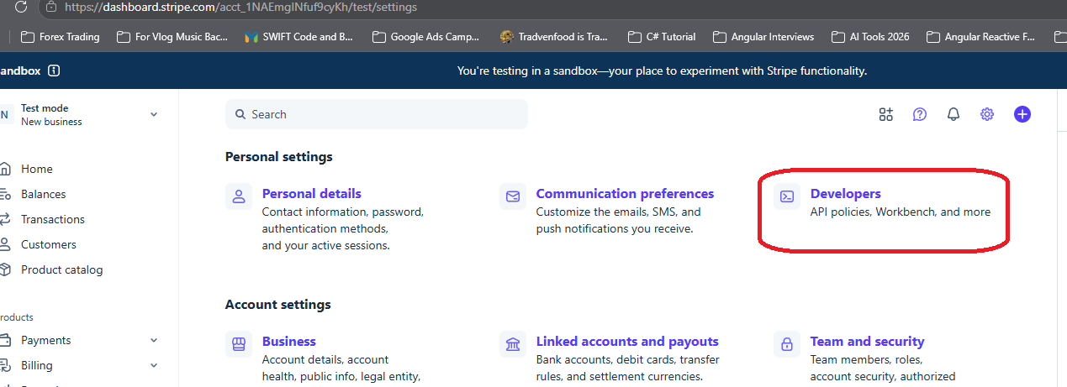

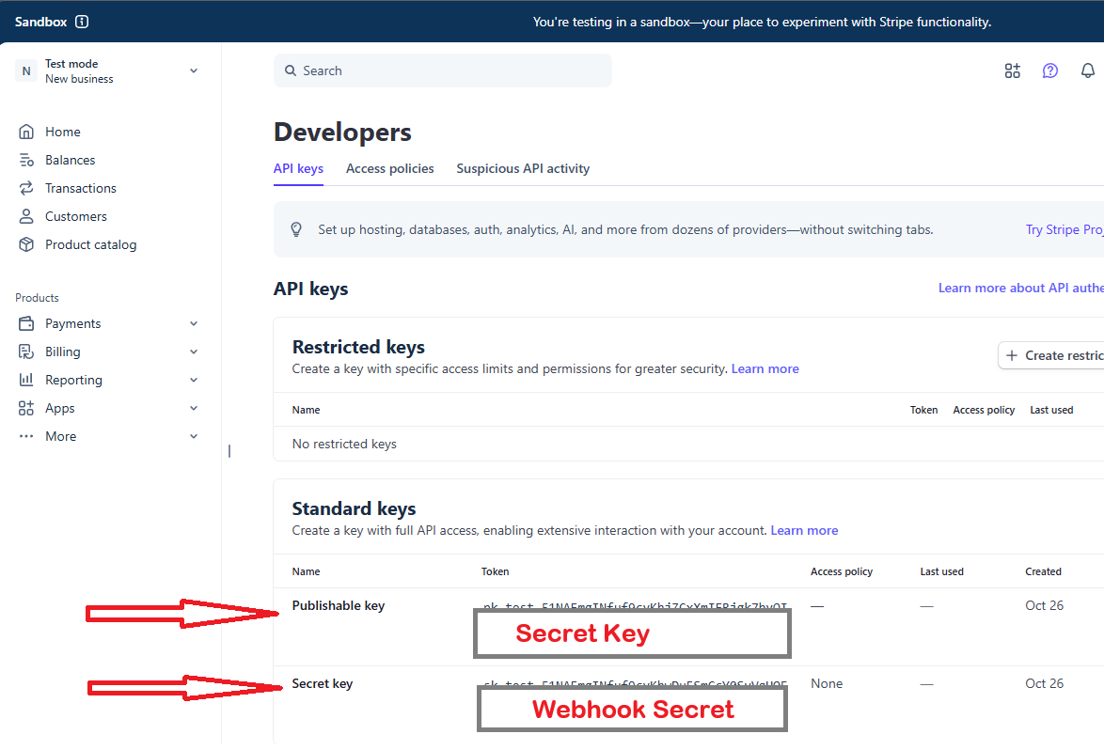
Then update the user-secrets on your C# project web api
dotnet user-secrets --project src/OnlineEbookShopV1.Api set "Stripe:SecretKey" "pk_test_5….."
dotnet user-secrets --project src/OnlineEbookShopV1.Api set "Stripe:WebhookSecret" "sk_test_51N…."

Set up a local listener for Stripe Payment
Run the following steps using the Stripe CLI
Show advanced options
1Download the Stripe CLI and log in with your Stripe account
$stripe login
2Forward events to your destination
$stripe listen --all-snapshot --forward-to localhost:4242/webhook
E.g.:
1. Run your web api project
stripe listen --forward-to localhost:5144/api/webhooks/stripe

Requires Stripe CLI v1.51.0. Upgrade the Stripe CLI.
3Trigger events with the CLI
$stripe trigger payment_intent.succeeded

